Examining the prevalence of soft palate morphology in individuals with cleft palate among patients referred to the dental schools of Guilan University of Medical Sciences during the years 2017-2019
Running Title: Soft Palate Morphology in Cleft Palate Individuals

Hamidreza Sharifipour Chokami¹, Farzaneh Ostovarrad², Pedram Javidi³
Rasoul Tabari Khomeiran⁴, Amirreza Rostami^{5*}

1- (D.D.S), General Dentist, School of Dentistry, Guilan University of Medical Sciences, Rasht, Iran
2- Assistant Professor, Department of Oral and Maxillofacial Radiology, School of Dentistry, Guilan University of Medical Sciences, Rasht, Iran
3- (D.D.S), General Dentist, Department of Orthodontics, School of Dentistry, Guilan University of Medical Sciences, Rasht, Iran
4- Associate Professor of Nursing, Guilan University of Medical Sciences, Rasht, Iran.
5- (D.D.S), General Dentist, Resident of Oral and Maxillofacial Radiology, Department of Orthodontics, School of Dentistry, Guilan University of Medical Sciences, Rasht, Iran

*Corresponding author:
Amirreza Rostami (D.D.S), General Dentist,
Resident of Oral and Maxillofacial Radiology,
Department of Oral and Maxillofacial Radiology
School of Dentistry, Guilan University of Medical Sciences, Rasht, Iran
Email: Arezarostami74@gmail.com
Phone: 0912-088-9647
Declarations
Ethical Considerations
Ethical code IR.GUMS.REC.1398.443
Funding
The financial support Guilan University of Medical Sciences is appreciated.
Authors’ Contributions
Hamidreza Sharifipour Chokami and Pedram Javidi sorted the patients according to the inclusion criteria and collected the data, interpreted it, Amirreza Rostami revised the data with major contribution in revising the manuscript, Amirreza Rostami, Farzaneh Ostovarrad and Rasoul Tabari Khomeiran were major contributor in writing and revising manuscript. All authors read and approved the final manuscript.
Conflict of Interests
The authors declare no conflict of interest in regard to this article.
Availability of data and material
Data available on request from the authors. The data that support the findings of this study are available from the corresponding author upon reasonable request.
Acknowledgements
The Guilan University of Medical Sciences is appreciated and acknowledged (Rasht, Iran).

Abstract
Introduction: The soft palate, a fibromuscular structure extending from the posterior edge of the hard palate, exhibits dysfunction in conditions such as cleft palate. Understanding its diverse morphologies across pathological conditions is critical for precise diagnosis and treatment. This study aimed to assess the prevalence of distinct soft palate morphologies in individuals with cleft palate.
Materials & Methods: This cross-sectional descriptive study involved patients with cleft palate referred to the School of Dentistry at Guilan University of Medical Sciences. Lateral cephalometric radiographs were reviewed, starting from the most recent, until the required sample size was achieved. Only one radiograph per patient was analyzed, excluding duplicates. Images were captured using a Sordex panoramic device (Helsinki, Finland) in proper positioning and exposure. Radiographs were manually analyzed on a negatoscope with tracing paper utilizing the YOU classification system.
Results: The results indicate that the Leaf-shaped type had the highest frequency, with 36 cases (40%), while the Straight line and S-shaped types both had the lowest frequency, each with 5 cases (5.6%). Moreover, there was no significant relationship between gender and morphology type (p = 0.86) found. Also, the findings indicated no significant association between age group and morphology type(p = 0.254).
Conclusion: The results revealed that the Leaf shaped type had the highest frequency, while the Straight line and S shaped types had the lowest frequencies. No significant correlation was found between gender or age and the type of morphology. In both genders, the Leaf shaped type was the most prevalent morphological type.
Keywords: Cleft palate; Velopharyngeal Sphincter; Radiography

Introduction
Facial development initiates during the fourth week of embryogenesis with the emergence of medial nasal prominences, lateral nasal prominences, and maxillary prominences. Cleft lip arises from incomplete fusion of the medial nasal prominences (either with each other or the maxillary prominences), whereas cleft palate results from failed fusion of the palatal shelves (typically between weeks 8–12 of gestation)(1, 2).
The soft palate, a posterior fibromuscular extension of the palate connected to the posterior margin of the hard palate, and comprises the depressor palatalis, levator palatalis, palatopharyngeal, palatoglossal, and hyoid muscles. It plays a vital role in swallowing, breathing, and speech(3). Dysfunction of the soft palate can result from various factors, including cleft lip and palate, enlarged adenoids, obstructive sleep apnea syndrome (OSAS), snoring, poorly maintained maxillary dentures, and craniofacial skeletal malocclusions. Understanding the normal anatomy and morphological variations of the soft palate is crucial for diagnosing and effectively managing these conditions(4, 5).
Cleft palate, a congenital disorder influenced by geographic, racial, and socioeconomic factors, has a global prevalence of 1 in 500–2,500 live births. Combined cleft lip and palate (35–50% of cases) is more frequent than isolated cleft palate (6, 7). Patients often experience swallowing difficulties, speech impairments, and aesthetic concerns, necessitating surgical and prosthetic interventions to improve function and psychosocial well-being (8, 9).
Velopharyngeal dysfunction (VPD) is a primary speech complication in cleft palate patients. Insufficient soft palate mobility impairs its seal with the posterior pharyngeal wall, causing hypernasality and articulation disorders(10). It refers to the impaired function of the movable structures responsible for controlling the velopharyngeal sphincter. Approximately 30 % of patients who undergo cleft palate repair surgery require secondary surgical intervention due to persistent velopharyngeal dysfunction. Understanding the normal anatomy and physiology of the velopharyngeal mechanism is the essential first step for an accurate diagnosis and effective treatment of children born with cleft lip and palate. The primary function of the velopharyngeal mechanism is to create a tight seal between the soft palate and the pharyngeal walls, thereby separating the oral and nasal cavities for various functions, including speech.
Velopharyngeal closure is accomplished through the coordinated contraction of several muscles, including the levator veli palatini, musculus uvulae, superior pharyngeal constrictor, palatopharyngeus, palatoglossus, and salpingopharyngeus(11, 12).
The primary goal of palatoplasty is to restore natural anatomy. Theoretically, palatoplasty improves the functional dynamics of the soft palate and pharyngeal walls by correcting dysmorphology in both the levator veli palatini and palatopharyngeus muscles(13). Pre- and postoperative anatomical assessments, along with short- and long-term outcome evaluations, enhance understanding of how different palatoplasty techniques influence soft palate structure. This is critical for optimizing velopharyngeal function, which underpins normal speech(14).
The Need ratio (soft palate length/pharyngeal depth) sereve as a diagnostic tool for assessing velopharyngeal function. In individuals with normal anatomy, this ratio ranges between 0.6 and 0.7. Among the six soft palate morphologies classified by the YOU system, type 6 (Crook-shaped) demonstrates the highest soft-palate-to-pharyngeal-depth ratio(15, 16). Considering this issue, examining the type of soft palate morphology in patients with cleft palate can help in the early diagnosis and prevention of surgery caused by velopharyngeal dysfunction.
Lateral cephalometric radiography is one of the most common extraoral radiographs after panoramic imaging, and it is applied in surgery and orthodontics treatment planning. It is used to measure anatomical distances and classify patients based on craniofacial morphology. As a standard diagnostic tool, it supports craniofacial assessment, treatment planning, progress monitoring, and outcome evaluation (17, 18). However, this technique projects three-dimensional craniofacial structures onto two-dimensional images, complicating accurate measurements even with optimal patient positioning (19). The main advantage of this technique is that the images obtained can be compared across different times and locations, allowing for the monitoring of growth, development, and treatment progress(20).
The soft palate has different morphologies in various diseases. Therefore, determining the different normal shapes of the soft palate in patients helps in the diagnosis and successful treatment of many complex cases and different diseases (21). Therefore, this study aimed to determine the frequency of soft palate morphology types in individuals with cleft palate among patients attending the dental schools of Guilan University of Medical Sciences from 2017-2019 using accessible lateral cephalometric radiographs.
Materials and Methods
This cross-sectional descriptive study (ethical code IR.GUMS.REC.1398.443) was conducted on lateral cephalometric radiographs of 90 patients with cleft palate who presented to the dental school at Guilan University of Medical Sciences from 2017 to 2019. The required sample size was determined based on the study by Deepak Samdani et al., (22).
n =$\frac{z^{2} p(1-p)}{d^{2}}$= $\frac{{\left(1.96\right)}^{2}(0.37)(0.63)}{({0.1)}^{2}}$=89
For sampling, lateral cephalometric radiographs of patients meeting the inclusion criteria were systematically reviewed, beginning with the most recent images and progressing to older ones until the predetermined sample size was achieved. Only one radiograph per patient was included in the analysis, and duplicate cases were excluded from the study. Additionally, radiographs with positioning inaccuracies or suboptimal image quality, as well as those from patients who had undergone prior surgical procedures, were excluded from the study population.
Lateral cephalometric radiographs were acquired using a Sordex panoramic device (Helsinki, Finland) with standardized positioning and optimal exposure parameters. Manual analysis was performed using a negatoscope by one maxillofacial radiologist and one orthodontist, using tracing paper. The study employed the YOU classification for soft palate morphology, comprising six types:
Type 1, Leaf-shaped: Mid-portion elevated toward oral/nasal cavities.
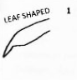

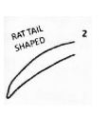
Type 2, Rat-tail shaped: Anterior swelling with distinct free-edge narrowing.

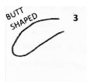
Type 3, Butt-shaped: Short, wide morphology with uniform thickness.

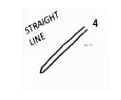
Type 4, Straight-line: Flat, planar configuration.

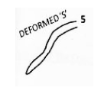
Type 5, Distorted soft palate: abnormal shape, structure, or function with S-like curvature.

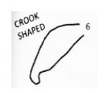
Type 6, Crook-shaped: Posterior segment curved anterosuperiorly, resembling a hook.

Statistical analysis:
The analysis was conducted on 90 patients (45 females and 45 males) aged 15 to 30 years, based on the YOU system, at both descriptive and inferential levels. The descriptive analyses employed mean, frequency percentage, standard deviation, minimum, and maximum, while for inferential comparisons, parametric data T-test for quantitative-qualitative variables, while non-parametric data utilized the Mann-Whitney test. The chi-square test evaluated associations between qualitative variables. Data processing was executed via SPSS software, version 19 and statistical significance was considered p ≤ 0.05.
Results:
Based on the obtained results from Table 1, the number of participants in the study was equal in terms of gender. Moreover, the highest frequency is observed in the 15–20-year age group, comprising 35.6 individuals (32%), while the lowest frequency is found in the 30–35-year age group, with 17.8 individuals (16%).
Table 2 represents the frequency distribution of different soft palate morphology types, based on YOU classification among individuals with cleft palate who attended dental schools at Guilan University of Medical Sciences. The results indicate that the Leaf-shaped type had the highest frequency, with 36 cases (40%), while the Straight line and S-shaped types both had the lowest frequency, each with 5 cases (5.6%) (Figure 1). In accordance with Fisher's exact test, there was no significant relationship between gender and morphology type was found (p >0.05) (Figure 2).
To analyze the relationship between morphology type and patient age group, Fisher's exact test was used, and the results are presented in Table 3. As shown, there was no significant association between age group and morphology type (p = 0.254) (Figure 3).
Discussion
The present study aimed to investigate the prevalence of different soft palate morphologies in patients with cleft palate who were referred to the dental schools of Guilan University of Medical Sciences between 2017 and 2019. Among the 90 participants, 45 (50%) were female and 45 (50%) were male. The age distribution revealed that the largest proportion of participants was in the 15–20-year age group, comprising 35.6% (32 individuals), followed by the 20–25, 25–30, and 30–35-year age groups, accounting for 26.7% (24 individuals), 20% (18 individuals), and 17.8% (16 individuals), respectively. Analysis of soft palate morphology, classified according to the YOU classification, indicated that the most common type was the leaf-shaped palate, observed in 40% (36 individuals). This was followed by the S-shaped (26.7%, 24 individuals), straight-line (13.3%, 12 individuals), crook-shaped (8.9%, 8 individuals), butt-shaped (5.6%, 5 individuals), and rat tail-shaped (5.6%, 5 individuals) morphologies.
Ismail et al., (23), was assessed the cephalometric association between various soft palate morphologies and different growth patterns and age groups in patients with skeletal Class I, II, and III malocclusion. The study included 96 males and 286 females, aged 11 to 30 years. All patients were classified according to their skeletal malocclusion type. The obtained results revealed that leaf-shaped soft palate was the most prevalent morphology (43.2%), while straight-line shape was the least common (2.9%) which was consistent with the results of our study. Also, the leaf-shaped soft palate was the most frequent type across all skeletal malocclusion classes, growth patterns, and in both genders. Therefore, they found a significant association between soft palate morphology and both skeletal malocclusion type and gender. However, no significant association was observed between soft palate morphology and growth pattern.
Dahal et al. (24), investigated the morphological variations of the soft palate among patients. The observed morphological types of the soft palate were as follows: rat-tail (42.4%), leaf-shaped (40.8%), butt-shaped (8.9%), straight-line (4.7%), S-shaped (1.9%), and crook-shaped (0.9%). Among males, the distribution was rat-tail (44.4%), leaf-shaped (41.1%), butt-shaped (8.4%), straight-line (3.9%), S-shaped (1.3%), and crook-shaped (0.6%). In females, the frequencies were rat-tail (40.6%), leaf-shaped (40.6%), butt-shaped (9.5%), straight-line (5.6%), S-shaped (2.5%), and crook-shaped (1.2%). The most frequently observed morphological shape in this study is inconsistent with our findings. Hence, they concluded that, the rat-tail form was the most prevalent soft palate morphology, followed by the leaf-shaped type in both sexes, while the crook-shaped form was the least common. No evidence of sexual dimorphism was found in the distribution of soft palate types.
In the study conducted by Chattopadhyay et al., (25),aimed on to investigate the diverse radiographic morphologies of the soft palate using digital lateral cephalometry and evaluated the differences in morphological types across gender groups. Among the 300 patients, six distinct types of soft palate morphology were identified. The Leaf shaped (52%) and Rat-tail shaped (25%) were the most prevalent, followed by Straight line shape (9.3%), Crooked appearance (7.3%), utt-like (3.3%), and S-shaped/distorted soft palate (3%). They concluded that, the soft palate can be broadly classified into six morphological types. This classification enhances our understanding of velar morphology in the median sagittal plane and serves as a valuable reference for research into velopharyngeal closure in individuals with cleft palate, obstructive sleep apnea, and other related conditions. In our study, the leaf-shaped palate emerged as the most prevalent morphology. This was followed by the rat tail shape, butt shape, crook shape, respectively. Also, straight-line and S-shaped types were the least common.
Subramaniam et al., (26), evaluated the morphological diversity of the soft palate in 200 individuals. The results showed that the rat tail-shaped soft palate was the most common type (40%), while the butt-shaped type was the least common (2%) in both genders. In this study, neither the most frequent nor the least frequent soft palate types matched the findings of our research. These differences may be attributed to variations in ethnicity, geographic location, and sample size between the studies.
Samdani et al., (22), conducted a study in the relationship between various soft palate shapes and types of malocclusion in both genders. The study consisted of 250 individuals aged 14 to 28 years and all participants were assessed for the type of malocclusion, and the morphology of the soft palate was evaluated on digital lateral cephalograms, classified according to the six patterns described in the YOU classification. The results showed that the rat tail-shaped soft palate was the most frequent (37.2%), while the S-shaped soft palate had the lowest frequency (6.8%) in both genders. Regarding the least common type, these findings were consistent with our study; however, in our study, the leaf-shaped soft palate was the most prevalent, which differs from their results.
Conclusion
The results indicated that the leaf-shaped soft palate had the highest frequency, while the straight-line and S-shaped types were the least common. Also, no significant association was found between soft palate morphology and either gender or age. In both sexes, the leaf-shaped morphology was the most prevalent.
Tables

Table1: Frequency and percentage distribution of patients by gender and age group.
Category | Group | Count | Percentage
Gender | Female | 45 | 50%
 | Male | 45 | 50%
Total |  | 90 | 100%
 | 15-20 | 32 | 35.6%
Age Group | 20-25 | 18 | 20%
 | 25-30 | 24 | 26.7%
 | 30-35 | 16 | 17.8%
Total |  | 90 | 100%

Table 2: Summary of the results for soft palate morphology types by gender according to the YOU classification.
Morphology Type |  | Gender |  | Frequency
 |  | Female | Male | (%)
 | Leaf shaped n (%) | 17(37.8) | 19 (42.2) | 36(40)
Rat tail shaped n (%) |  | 14 (31.1) | 10 (22.2) | 24(26.7)
Butt shaped n (%) |  | 5 (11.1) | 7 (15.6) | 12(13.3)
Straight line n (%) |  | 2 (4.4) | 3 (6.7) | 5(5.6)
S shaped n (%) |  | 2 (4.4) | 3 (6.7) | 5(5.6)
Crook shaped n (%) |  | 5 (11.1) | 3 (6.7) | 8(8.9)
Total |  |  |  | 90(100)
*p-value |  | 2.17 | 0.868
* Fisher's Exact Test
Table 3: Relationship Between Soft Palate Morphology Type and Age Group.
Morphology Type |  |  | Age | Group
 |  | 15-20 | 20-25 | 25-30 | 30-35
 | Leaf shaped n (%) | 12(37.5) | 9(50) | 9(37.5) | 6(37.5)
Rat tail shaped n (%) |  | 5(15.6) | 5(27.8) | 9(37.5) | 5(31.3)
Butt shaped n (%) |  | 5(15.6) | 2(11.1) | 3(12.5) | 2(12.5)
Straight line n (%) |  | 3(9.4) | 2(11.1) | 0(0) | 0(0)
S shaped n (%) |  | 2(6.3) | 0(0) | 0(0) | 3(18.8)
Crook shaped n (%) |  | 5(15.6) | 0(0) | 3(12.5) | 0(0)
*p-value |  | 16.60 | 0.254
* Fisher's Exact Test

Figures

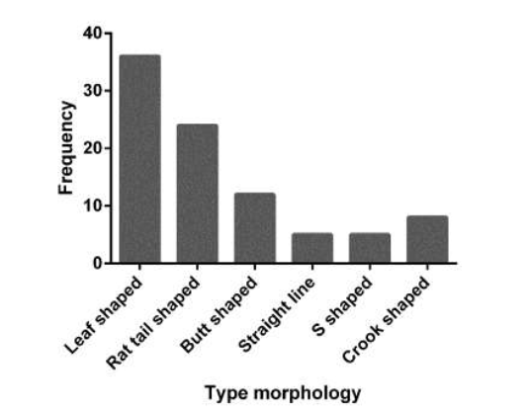
Figure 1: Frequency of soft palate morphology types in individuals with cleft palate based on the YOU classification.

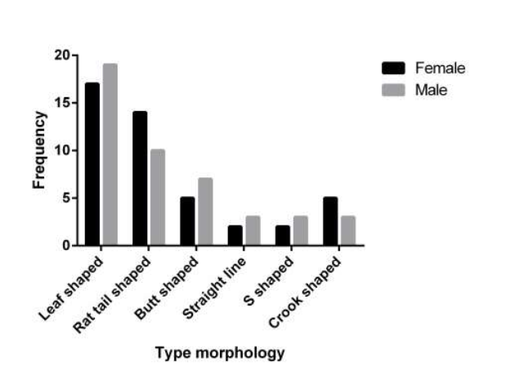
Figure 2: Distribution of soft palate morphology types by gender according to the YOU classification

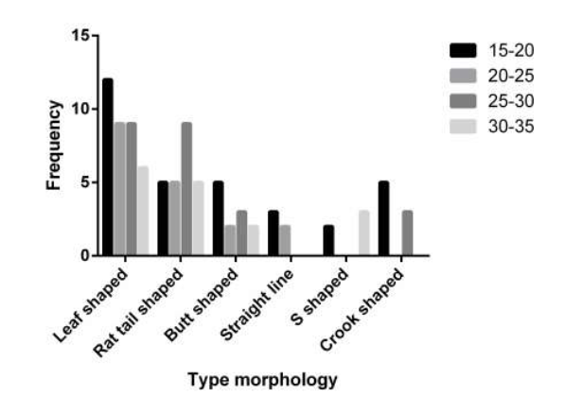
Figure 3: Frequency of morphology types based on the YOU classification in individuals with cleft palate based on age group.

References

1. Hammond NL, Dixon MJ. Revisiting the embryogenesis of lip and palate development. Oral diseases. 2022;28(5):1306-26.
2. Naini FB, Cobourne MT, Garagiola U, McDonald F, Wertheim D. Nasofacial angle and nasal prominence: a quantitative investigation of idealized and normative values. Journal of Cranio-Maxillofacial Surgery. 2016;44(4):446-52.
3. Cho JH, Kim JK, Lee HY, Yoon JH. Surgical anatomy of human soft palate. The Laryngoscope. 2013;123(11):2900-4.
4. Helwany M, Rathee M. Anatomy, head and neck, palate. StatPearls [internet]: StatPearls Publishing; 2023.
5. Pham Q, Lentner M, Hu A. Soft palate injuries during orotracheal intubation with the videolaryngoscope. Annals of Otology, Rhinology & Laryngology. 2017;126(2):132-7.
6. Li F, Wang H-T, Chen Y-Y, Wu W-L, Liu J-Y, Hao J-S, et al. Cleft relapse and oronasal fistula after Furlow palatoplasty in infants with cleft palate: incidence and risk factors. International Journal of Oral and Maxillofacial Surgery. 2017;46(3):275-80.
7. Sakran KA, Yin J, Yang R, Elayah SA, Alkebsi K, Zhang S, et al. Early cleft palate repair by a modified technique without relaxing incisions. The Cleft Palate Craniofacial Journal. 2024;61(4):646-53.
8. Sakran KA, Wu M, Alkebsi K, Mashrah MA, Al‐Rokhami RK, Wang Y, et al. The sommerlad–furlow modified palatoplasty technique: postoperative complications and implicating factors. The Laryngoscope. 2023;133(4):822-9.
9. Cheng X, Bo Z, Yin H, Yang K, Li J, Shi B. Age and preoperative velar closure ratio are significantly associated with surgical outcome of Furlow double-opposing Z-plasty in palatal re-repair. Journal of Oral and Maxillofacial Surgery. 2020;78(3):431-9.
10. Chiang SN, Fotouhi AR, Grames LM, Skolnick GB, Snyder-Warwick AK, Patel KB. Buccal myomucosal flap repair for velopharyngeal dysfunction. Plastic and reconstructive surgery. 2023;152(4):842-50.
11. Espel JP, Hohman MH, Winters R. Cleft Palate Repair. StatPearls [Internet]: StatPearls Publishing; 2023.
12. Nachmani A, Masalha M, Kassem F. Phonological profile of patients with velopharyngeal dysfunction and palatal anomalies. Journal of Speech, Language, and Hearing Research. 2021;64(12):4649-63.
13. Sakran K, Liu R, Yu T, Al-Rokhami R, He D. A comparative study of three palatoplasty techniques in wide cleft palates. International Journal of Oral and Maxillofacial Surgery. 2021;50(2):191-7.
14. Pang K, Pang E, Pang K, Rotenberg B. Anterior palatoplasty in the treatment of obstructive sleep apnoea-a systemic review. Acta Otorhinolaryngologica Italica. 2017;38(1):1.
15. Khoja A. Soft palate dimensions and nasopharyngeal depth (need’s ratio) in different sagittal and vertical skeletal patterns: a lateral cephalometric study. Adv Dent & Oral Health. 2018;8(1):555726.
16. Preetha VM, Vardhan BH, Gopal KS, Lankupalli AS. Assessing the prevalence of velopharyngeal dysfunction and obstructive sleep apnea by correlating cone beam computed tomography parameters of soft palate with the stop bang questionnaire. Journal of Indian Academy of Oral Medicine and Radiology. 2021;33(3):294-300.
17. Heil A, Lazo Gonzalez E, Hilgenfeld T, Kickingereder P, Bendszus M, Heiland S, et al. Lateral cephalometric analysis for treatment planning in orthodontics based on MRI compared with radiographs: A feasibility study in children and adolescents. PloS one. 2017;12(3):e0174524.
18. Ferrario VF, Sforza C, Miani A, Tartaglia G. Craniofacial morphometry by photographic evaluations. American Journal of Orthodontics and Dentofacial Orthopedics. 1993;103(4):327-37.
19. Guinot‐Barona C, Alonso Pérez‐Barquero J, Galán López L, Barmak AB, Att W, Kois JC, et al. Cephalometric analysis performance discrepancy between orthodontists and an artificial intelligence model using lateral cephalometric radiographs. Journal of Esthetic and Restorative Dentistry. 2024;36(4):555-65.
20. Hussain S, Mubeen I, Ullah N, Shah SSUD, Khan BA, Zahoor M, et al. Modern diagnostic imaging technique applications and risk factors in the medical field: a review. BioMed research international. 2022;2022(1):5164970.
21. Kuijpers MA, Chiu Y-T, Nada RM, Carels CE, Fudalej PS. Three-dimensional imaging methods for quantitative analysis of facial soft tissues and skeletal morphology in patients with orofacial clefts: a systematic review. PloS one. 2014;9(4):e93442.
22. Samdani D, Saigal A, Garg E. Correlation of morphological variants of soft palate and types of malocclusion: A digital lateral cephalometric study. Journal of Indian Academy of Oral Medicine and Radiology. 2015;27(3):366-71.
23. Ismail N, Shaikh A, Khan SA. Cephalometric Association Between Various Shapes of Soft Palate with Different Growth Pattern and Age Groups in Skeletal Class I, II and III Malocclusion. Journal of The Pakistan Dental Association. 2023;32(3).
24. Dahal S, Gupta SP, Singh AK, Baral R, Giri A. The Morphological Variation of the Soft Palate in Hospital Visiting Patients. 2022.
25. Chattopadhyay S, Arora R, Kishor A, Singh S, Alok A. Morphological Variations Of Soft Palate: A Digital Cephalometric Study.
26. Subramaniam N, Muthukrishnan A. Assessment of various shapes of Soft Palate-A Retrospective Lateral Cephalometric Study. Research Journal of Pharmacy and Technology. 2018;11(12):5233-7.

