**Root and Canal Morphology Variations in Maxillary Premolars: A Cross-Sectional Study in Rasht, Iran**

**Abstract**

**Introduction**: Successful root canal treatment depends on thoroughly understanding root canal morphology. Variations in this anatomy are common and can significantly impact treatment outcomes. This study aimed to investigate the prevalence of root and canal configurations in maxillary premolars and their association with age, gender, and jaw side in a specific Iranian population.

**Methods**: A cross-sectional study analyzed CBCT images of maxillary premolars from patients treated at oral and maxillofacial radiology clinics in Rasht City, Iran, between 2021 and 2022. Root number and canal morphology (Vertucci classification) were determined. Statistical analysis assessed associations between these variables and age, gender, and jaw side. The significance level of the tests was set at 0.05.

**Results**: A total of 1732 maxillary premolars were analyzed. Maxillary first premolars showed a nearly equal distribution of single- (46.1%) and double-rooted (52.9%) teeth, while maxillary second premolars were predominantly single-rooted (91.1%). Vertucci types II and IV were most frequent in single-rooted maxillary first premolars, while type I predominated in second premolars. A statistically significant association was found between canal morphology and both gender (p < 0.05) and age (p < 0.05), but not jaw side. Males had a higher frequency of multi-rooted teeth, and canal complexity increased with age.

**Conclusions**: This study provides valuable data on maxillary premolars' root and canal morphology in a specific Iranian population. The findings highlight significant morphological variations related to tooth type, gender, and age affecting endodontic treatment planning. Pre-operative CBCT assessment may improve treatment outcomes.

**Keywords:** [Bicuspid](https://www.ncbi.nlm.nih.gov/mesh/?term=premolar), [Root Canal Therapy](https://www.ncbi.nlm.nih.gov/mesh/68012390), [Root Canal Preparation](https://www.ncbi.nlm.nih.gov/mesh/68018915), [Cone-Beam Computed Tomography](https://www.ncbi.nlm.nih.gov/mesh/?term=computed+tomography%2C+cone+beam), [Endodontics](https://www.ncbi.nlm.nih.gov/mesh/68004708)

**Introduction**

Successful root canal therapy (RCT) relies on complete debridement of the root canal system.[1, 2] Inadequate knowledge of root anatomy can compromise treatment outcomes and lead to tooth loss due to incomplete cleaning.[3, 4]

With their complex root canal anatomy, maxillary premolars are particularly challenging for RCT.(1, 2) Variations in root number and canal configuration contribute to this complexity, with second premolars exhibiting greater morphological diversity than first premolars.(3, 4)

Previous studies on the prevalence of root numbers in maxillary first premolars have exhibited significant variability both within and between populations. In Iranian studies, the prevalence of single-rooted teeth ranged from 19.5% to 72.4%, double-rooted teeth from 27.6% to 79.4%, and triple-rooted teeth from 0.0% to 1.85%. Comparable global studies reported a similar range, with single-rooted teeth accounting for 23.7% to 72.22%, double-rooted teeth for 26.54% to 75.1%, and triple-rooted teeth for 0.3% to 2.6%.(2, 4-12)

The investigations into the prevalence of root numbers in maxillary second premolars among the Iranian population revealed that single-rooted teeth constituted 91% to 98% of cases, double-rooted teeth 2% to 8.5%, and triple-rooted teeth 0.0% to 0.5%. Similar studies conducted in other populations demonstrated a comparable range, with single-rooted teeth accounting for 82.1% to 91.9%, double-rooted teeth for 8.1% to 17.9%, and triple-rooted teeth for 0.0% to 1%.(2, 6, 7, 10, 12)

Furthermore, studies on the canal morphology of maxillary premolars based on the Vertucci classification have consistently reported types IV, II, and I as the most frequent in maxillary first premolars. Similarly, types I, II, and IV were found to be the most common in maxillary second premolars.(2-4, 6, 7, 9-12)

Therefore, the accurate assessment of root canal morphology is crucial for successful RCT. While various methodologies exist, including decalcification and sectioning, radiographic visualization, and macroscopic assessment, cone beam computed tomography (CBCT) offers superior three-dimensional visualization.(5)

CBCT's cost-effectiveness, reduced radiation exposure, high resolution, and rapid scan time have led to its widespread adoption in various dental specialties, including endodontics.(8, 13, 14) Furthermore, CBCT provides additional patient-specific information that may influence root canal morphology, such as age, gender, and ethnicity.(15) Significantly, variations in root canal anatomy can be attributed to race, genetics, diet, geographic location, gender, and age.(1)

While several studies have investigated maxillary premolar morphology in different Iranian regions, further regional investigations are necessary to account for potential ethnic and genetic influences on root canal anatomy. Therefore, this study aimed to determine the frequency of various root and canal anatomy types in maxillary premolars using CBCT images of patients referred to oral and maxillofacial radiology clinics in Rasht City in 2021-2022.

**Materials and Methods**

This cross-sectional analytical study utilized CBCT images from patients who visited maxillofacial radiology clinics in Rasht City between 2021 and 2022. This study was approved by the Ethics Committee of the Guilan University of Medical Sciences (IR.GUMS.REC.1401.091).The CBCT images, initially obtained for implant treatment planning, prosthetics, orthodontic surgery, and endodontics, were collected, and selected maxillary premolars meeting specific criteria.

Inclusion criteria included patients aged 16 to 60 years with intact maxillary premolars exhibiting complete root formation and no history of RCT. Teeth with restorations, external or internal root resorption, periapical lesions, posts, calcifications, unacceptable dental conditions, or low-quality images were excluded. The age range was chosen to encompass a broad adult population with generally complete root development while excluding potential confounding factors associated with aging. Restorations were excluded to ensure an accurate inherent root canal morphology assessment.

All CBCT images were acquired using a Newtom Go device (settings: 90 kV, 15 mA, 100 x 100 mm maximum FOV, 80 µm voxel size) and evaluated using NNT Viewer software.

A dental student whose training was confirmed in a pilot study performed image observation and data collection. The maxillary premolars were examined for root and canal morphology using axial, coronal, and sagittal views of CBCT images. Coronal and sagittal views were used to aid in diagnosis in the axial view, from the floor of the pulp chamber to the apex.

Teeth were divided into single-rooted, two-rooted, and three-rooted based on the number of roots. Based on the Vertucci classification, the canal morphology was divided into Vertucci types I to VIII.(16)

After collecting data based on the research checklist, the data was entered into IBM SPSS v26. To determine the frequency of the root anatomy and canal morphology of the examined teeth, frequency, percentage, and 95% confidence intervals were used. The chi-square test was used to compare the frequency of canals based on the number of roots, tooth type, age, gender, and tooth side. The level of significance of the tests was considered to be 0.05.

**Results**

A total of 1732 maxillary premolars were analyzed from 753 CBCT images. Maxillary first premolars (n=924, 53.35%) were slightly more frequent than maxillary second premolars (n=808, 46.65%). The sample included 774 male and 958 female teeth, with an average patient age of 36.9 ± 13.3 years. Teeth were categorized based on the number of roots (single, double, triple) and canal morphology (Vertucci types I-VIII).

Maxillary first premolars primarily exhibited a single root (46.1%) with Vertucci type II canals. Approximately 52.9% were double-rooted, with both roots displaying Type I canals. Only 1% of teeth presented with three roots, all of which were Type I. Maxillary second premolars were predominantly single-rooted (91.1%), with Vertucci type I canals being the most common. A small portion (8.8%) were two-rooted, primarily with type I canals. A three-rooted premolar with all type I canals was found in a sporadic case. (see Figure 1 and Figure 2 for CBCT images)

Figure 3 presents a stacked bar chart summarizing the distribution of Vertucci canal types across maxillary first and second premolars. The chart highlights the predominance of Vertucci Type I canals in second premolars, accounting for the majority of configurations, followed by lower frequencies of Types II, III, and IV.

Analysis of root numbers revealed a statistically significant difference between genders (p < 0.001). Females showed a significantly higher prevalence of single-rooted teeth (74% vs. 58.6% in males), while males had a higher frequency of double-rooted teeth. No significant differences in root number were observed across age groups (p = 0.453) or between the right and left sides of the jaw (p = 0.599). [Table 1]

Canal morphology analysis revealed a significant association between gender (p = 0.031) and age (p = 0.001). Specifically, the prevalence of Vertucci type I and IV canals decreased with age, while the frequency of type II canals increased. No significant differences in canal type were observed between jaw sides (p = 0.576). [Table 2]

**Discussion**

A comprehensive understanding of root morphology and canal anatomy is a prerequisite for achieving a clean and disinfected root canal during endodontic treatment. Many challenges encountered during root canal therapy can be directly attributed to an inadequate understanding of dental morphology.(17) CBCT is one of the methods for evaluating root canal morphology, playing a significant role in endodontic diagnosis, treatment planning, and follow-ups.(9, 18)

This study utilized CBCT imaging to investigate the prevalence of root and canal configurations in maxillary premolars within a Rasht City, Iran, population and to explore the influence of age, gender, and jaw side.

Maxillary first premolars in our sample exhibited a prevalence of single roots (46.1%), closely mirroring findings by Mashyakhy (19) and Abella et al. (2). However, this contrasts with studies reporting higher proportions of single-rooted teeth (3, 20, 21), potentially reflecting ethnic or geographic variations. The higher prevalence of double-rooted teeth (52.9%) in our cohort aligns with Loh's observations (22) but differs from some studies reporting a different distribution.(2)

For maxillary second premolars, the overwhelming predominance of single roots (91.1%) is consistent with several studies [19, 20], but other reports show a substantially higher frequency of two-rooted teeth.[1, 6, 23, 24]  These discrepancies likely stem from variations in sample populations, methodologies, and potentially genetic influences.

In single-rooted maxillary first premolars, Vertucci types II, IV, and I were most prevalent (46.5%, 38.3%, and 12.7%, respectively), broadly consistent with Asheghi et al. (20), and Popovic et al.(23) Nevertheless, diverging from others shows a higher prevalence of type I (24) or different rank orders.(3, 25, 26) The absence of types VII and VIII mirrors many studies, suggesting these are rare configurations. Double- and triple-rooted teeth predominantly showed type I canals in buccal and palatal roots, a pattern observed in other studies. In maxillary second premolars, the prevalence of types I, II, and IV in single-rooted teeth was high and aligned with several studies (2, 20, 23, 24, 26, 27),  but not all.(25, 28, 29) These discrepancies underscore the heterogeneity of canal morphology across diverse populations.

Our findings reveal a statistically significant association between gender, root number, and canal configuration. Males showed a higher prevalence of multiple-rooted teeth and complex canal configurations, while females demonstrated a higher frequency of single-rooted teeth. This is consistent with some studies (30, 31), but contrasts with others, who found no gender association.(32-34) This divergence suggests that the influence of gender on root morphology may be population-specific and warrants further investigation.

While the number of roots remained relatively consistent across age groups, a statistically significant age-related variation in Vertucci types emerged (p = 0.001). Specifically, a decrease in type I and IV configurations and an increase in type II configurations were observed with advancing age, consistent with some studies (35, 36) but not others.(37) These changes may be attributed to developmental processes, hormonal fluctuations, dietary factors, mechanical stresses, or genetic predispositions, necessitating further research to elucidate the mechanisms fully.

No statistically significant differences were observed in root number or Vertucci-type distribution between the right and left sides of the jaw. This aligns with most studies (19, 30, 32, 34), suggesting systemic factors may be more influential in determining root canal configurations than local variations. However, this contradicts some findings reporting laterality differences (38), potentially due to population-specific factors.

The findings highlight the substantial variability in root and canal morphology of maxillary premolars, emphasizing the importance of preoperative assessment, ideally with CBCT, for optimal endodontic treatment planning. Acknowledging gender—and age-related variations can improve treatment predictability and reduce the risk of complications. Further research on the genetic and environmental factors influencing these variations is warranted.

Despite the valuable insights provided by this study, several limitations should be acknowledged. First, the retrospective nature of CBCT image selection may introduce sampling bias, as most of the images were obtained initially for clinical purposes unrelated to endodontic evaluation. Second, the study was confined to a single geographic region, potentially limiting the generalizability of the findings to broader populations with different ethnic and genetic backgrounds. Additionally, although CBCT offers high-resolution imaging, the interpretation of canal configurations remains partially operator-dependent and subject to inter-observer variability.

Future studies should include larger and more diverse populations across multiple regions to validate and expand upon these findings. Incorporating advanced machine learning algorithms for image analysis could also enhance the objectivity and reproducibility of morphological assessments. Moreover, prospective studies evaluating clinical outcomes about anatomical complexity would further elucidate the clinical relevance of canal morphology variations and support the development of predictive models for treatment planning.

**Conclusion**

This cross-sectional analysis offers a comprehensive anatomical assessment of maxillary premolars in an Iranian subpopulation using CBCT imaging. The study confirms substantial morphological variability, with maxillary first premolars exhibiting a nearly equal distribution of single and double roots and maxillary second premolars predominantly presenting a single-rooted configuration. Canal morphology patterns, particularly the predominance of Vertucci types II and IV in first premolars and type I in second premolars, were significantly associated with gender and age. These findings underscore the necessity for individualized preoperative assessment to optimize endodontic treatment strategies. Future investigations should explore the genetic, environmental, and developmental factors contributing to these anatomical differences, thereby enhancing the precision of endodontic care across diverse populations.

**References**

1. Shi, Z-Y, Hu, N, Shi, X-W*, et al.* Root Canal Morphology of Maxillary Premolars among the Elderly. *Chinese Medical Journal*. 2017;**130**(24):2999-3000.

2. Al‑Zubaidi, SM, Almansour, MI, Al Mansour, NN*, et al.* Assessment of root morphology and canal configuration of maxillary premolars in a Saudi subpopulation: a cone-beam computed tomographic study. *BMC Oral Health*. 2021;**21**(1):1-11.

3. Liu, X, Gao, M, Ruan, J*, et al.* Root canal anatomy of maxillary first premolar by microscopic computed tomography in a Chinese adolescent subpopulation. *BioMed Research International*. 2019;**2019**.

4. Nagaş, IÇ, Eğilmez, F, Kivanç, BH. The permanent maxillary and mandibular premolar teeth. *Dental Anatomy*. 2018.

5. Grover, C, Shetty, N. Methods to study root canal morphology: A review. *ENDO (Lond Engl)*. 2012;**6**(3):171-82.

6. Iqbal, A. The factors responsible for endodontic treatment failure in the permanent dentitions of the patients reported to the college of dentistry, the University of Aljouf, Kingdom of Saudi Arabia. *Journal of clinical and diagnostic research: JCDR*. 2016;**10**(5):ZC146.

7. Jamleh, A, Aljohani, SM, Alzamil, FF*, et al.* Assessment of the educational value of endodontic access cavity preparation YouTube video as a learning resource for students. *Plos one*. 2022;**17**(8):e0272765.

8. Kamburoğlu, K. Use of dentomaxillofacial cone beam computed tomography in dentistry. *World journal of radiology*. 2015;**7**(6):128.

9. Lin, Z, Hu, Q, Wang, T*, et al.* Use of CBCT to investigate the root canal morphology of mandibular incisors. *Surgical and Radiologic Anatomy*. 2014;**36**(9):877-82.

10. Raj, UJ, Mylswamy, S. Root canal morphology of maxillary second premolars in an Indian population. *Journal of conservative dentistry: JCD*. 2010;**13**(3):148.

11. Awawdeh, L, Abdullah, H, Al-Qudah, A. Root form and canal morphology of Jordanian maxillary first premolars. *Journal of Endodontics*. 2008;**34**(8):956-61.

12. Gulabivala, K, Aung, T, Alavi, A*, et al.* Root and canal morphology of Burmese mandibular molars. *International endodontic journal*. 2001;**34**(5):359-70.

13. White, SC, Pharoah, MJ. *White and Pharoah's Oral Radiology: Principles and Interpretation*: Elsevier Health Sciences; 2018.

14. Venkatesh, E, Elluru, SV. Cone beam computed tomography: basics and applications in dentistry. *Journal of istanbul University faculty of Dentistry*. 2017;**51**(3 Suppl 1):102-21.

15. Ahmed, HMA. A critical analysis of laboratory and clinical research methods to study root and canal anatomy. *International Endodontic Journal*. 2022;**55**:229-80.

16. Vertucci, F, Seelig, A, Gillis, R. Root canal morphology of the human maxillary second premolar. *Oral Surg Oral Med Oral Pathol*. 1974;**38**(3):456-64.

17. Guven, EP. Root canal morphology and anatomy. *Human Teeth-Key Skills and Clinical Illustrations*. 2019.

18. Martins, JN, Versiani, MA. CBCT and micro-CT on the study of root canal anatomy. *The root canal anatomy in permanent dentition*. 2019:89-180.

19. Mashyakhy, M. Anatomical evaluation of maxillary premolars in a Saudi population: an in vivo cone-beam computed tomography study. *The Journal of Contemporary Dental Practice*. 2021;**22**(3):284-9.

20. Asheghi, B, Momtahan, N, Sahebi, S*, et al.* Morphological evaluation of maxillary premolar canals in Iranian population: a cone-beam computed tomography study. *Journal of Dentistry*. 2020;**21**(3):215.

21. Kfir, A, Mostinsky, O, Elyzur, O*, et al.* Root canal configuration and root wall thickness of first maxillary premolars in an Israeli population. A Cone-beam computed tomography study. *Scientific Reports*. 2020;**10**(1):1-8.

22. Loh, H. Root morphology of the maxillary first premolar in Singaporeans. *Australian Dental Journal*. 1998;**43**(6):399-402.

23. Popović, M, Papić, M, Acović, A*, et al.* Cone-beam computed tomography study of root number and root canal configuration of premolars in Serbian population. *Medicinski pregled*. 2018;**71**(3-4):100-7.

24. Nazeer, MR, Khan, FR, Ghafoor, R. Evaluation of root morphology and canal configuration of Maxillary Premolars in a sample of Pakistani population by using Cone Beam Computed Tomography. *Journal of the College of Physicians and Surgeons--Pakistan*. 2018;**68**(3):423.

25. Elkady, AM, Allouba, K. Cone beam computed tomographic analysis of root and canal morphology of maxillary premolars in Saudi subpopulation. *Dental J*. 2013;**59**:3429.

26. Celikten, B, Orhan, K, Aksoy, U*, et al.* Cone-beam CT evaluation of root canal morphology of maxillary and mandibular premolars in a Turkish Cypriot population. *BDJ open*. 2016;**2**(1):1-5.

27. Alqedairi, A, Alfawaz, H, Al-Dahman, Y*, et al.* Cone-beam computed tomographic evaluation of root canal morphology of maxillary premolars in a Saudi population. *BioMed Research International*. 2018;**2018**.

28. Partovi, M, Mozzafari, S. Root canal morphology of human maxillary second premolar. 2005.

29. Elnour, M, Khabeer, A, AlShwaimi, E. Evaluation of root canal morphology of maxillary second premolars in a Saudi Arabian sub-population: An in vitro microcomputed tomography study. *The Saudi dental journal*. 2016;**28**(4):162-8.

30. Pan, JYY, Parolia, A, Chuah, SR*, et al.* Root canal morphology of permanent teeth in a Malaysian subpopulation using cone-beam computed tomography. *BMC Oral Health*. 2019;**19**(1):1-15.

31. Martins, JN, Ordinola‐Zapata, R, Marques, D*, et al.* Differences in root canal system configuration in human permanent teeth within different age groups. *International Endodontic Journal*. 2018;**51**(8):931-41.

32. Olczak, K, Pawlicka, H, Szymański, W. Root form and canal anatomy of maxillary first premolars: a cone-beam computed tomography study. *Odontology*. 2022;**110**(2):365-75.

33. Masiga, M, Maina, S. Internal root morphology of the maxillary first premolars in Kenyans of African descent. *East African Medical Journal*. 2010;**87**(1):20-4.

34. Abella, F, Teixidó, LM, Patel, S*, et al.* Cone-beam computed tomography analysis of the root canal morphology of maxillary first and second premolars in a Spanish population. *Journal of Endodontics*. 2015;**41**(8):1241-7.

35. Hu, R, Xie, W, Hu, Y*, et al.* Root canal anatomy of maxillary second premolars at various ages observed by cone-beam CT. *Zhonghua kou Qiang yi xue za zhi= Zhonghua Kouqiang Yixue Zazhi= Chinese Journal of Stomatology*. 2019;**54**(11):733-8.

36. Solomonov, M, Kim, H-C, Hadad, A*, et al.* Age-dependent root canal instrumentation techniques: a comprehensive narrative review. *Restorative Dentistry & Endodontics*. 2020;**45**(2).

37. Aslam, N, Asif, M, Nadeem, A*, et al.* Radiographic And Clinical Assessment Of Two Canals In The Maxillary Second Premolar. *Journal of Ayub Medical College, Abbottabad: JAMC*. 2021;**33**(4):S734-S7.

38. Ok, E, Altunsoy, M, Nur, BG*, et al.* A cone-beam computed tomography study of root canal morphology of maxillary and mandibular premolars in a Turkish population. *Acta Odontologica Scandinavica*. 2014;**72**(8):701-6.

**Figures:**

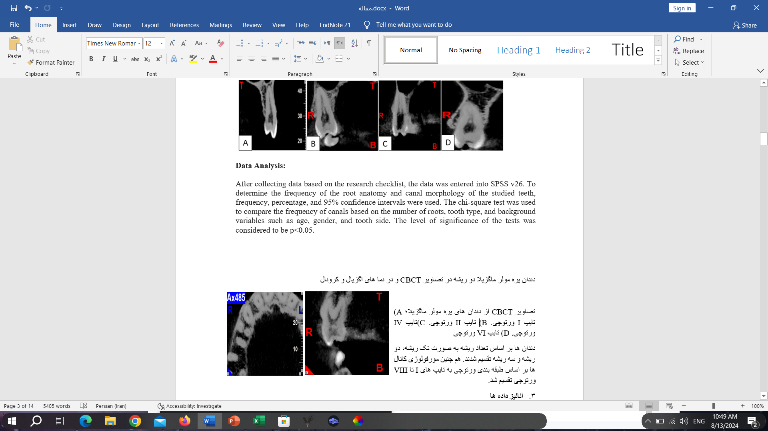

Figure . Double-rooted maxillary premolar in CBCT images and in axial (left) and coronal (right) views

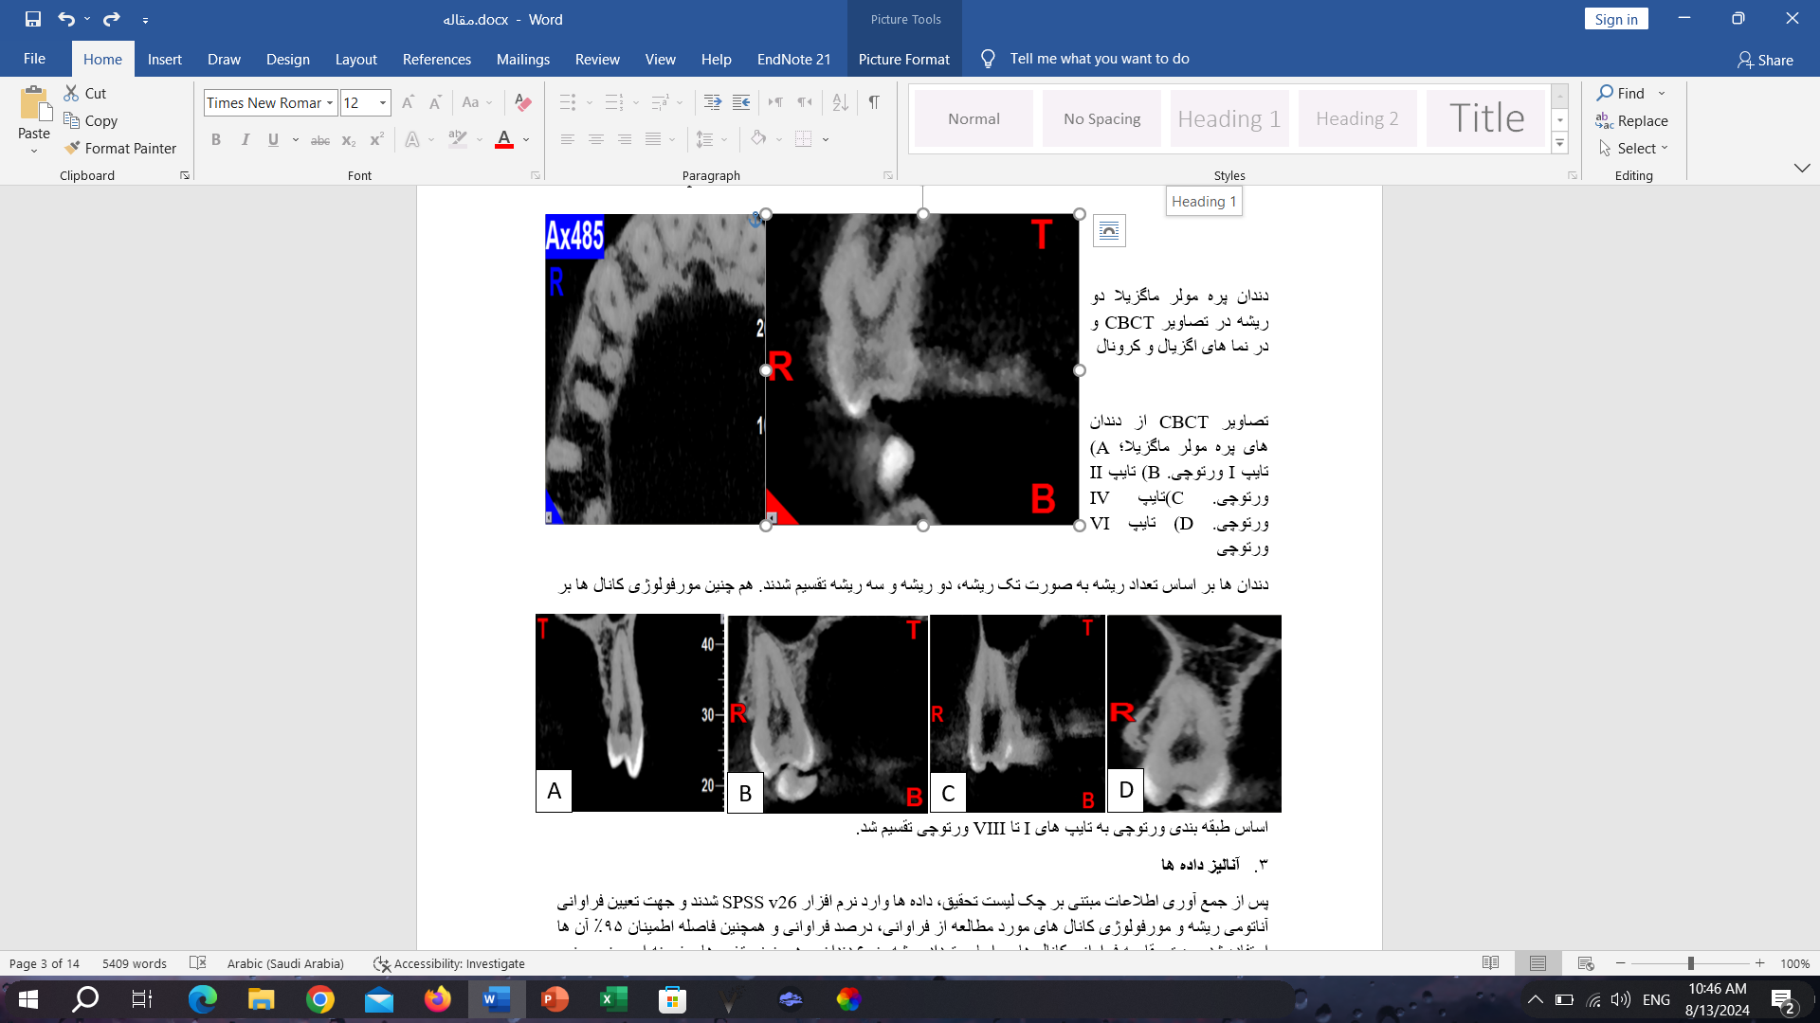

Figure 2. CBCT images of maxillary premolar; A) Type I Vertucci. B) Type II Vertucci. C) Type IV Vertucci. D) Type VI Vertucci

**Charts:**

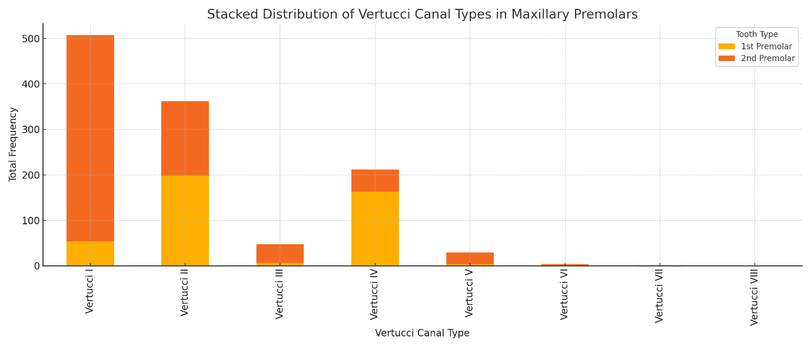

Figure . Stacked Distribution of Vertucci Canal Types in Maxillary Premolars

**Tables:**

Table 1. Frequency distribution of the number of roots according to gender, age, jaw side

| Variables | | Number of Roots | | | Total  N (%) | *p-valuea* |
| --- | --- | --- | --- | --- | --- | --- |
| 1  N (%) | 2  N (%) | 3  N (%) |
| Gender | **Male** | 454 (58.66) | 313 (40.44) | 7 (0.90) | 774 (44.69) | <0.001* |
| **Female** | 708 (73.90) | 247 (25.78) | 3 (0.31) | 958 (55.31) |
| Age | **16-30** | 350 (65.18) | 183 (34.08) | 4 (0.74) | 537 (31.00) | 0.453 |
| **30-50** | 557 (69.18) | 253 (30.34) | 4 (0.48) | 834 (48.15) |
| **50-60** | 235 (65.10) | 124 (34.35) | 2 (0.55) | 361 (20.85) |
| Jaw side | **Right** | 614 (66.59) | 304 (32.97) | 4 (0.43) | 922 (53.23) | 0.599 |
| **Left** | 548 (67.65) | 256 (31.6) | 6 (0.74) | 810 (46.77) |

*a chi-square test*

Table 2. Frequency distribution of the canal type (Vertucci's classification) according to gender, age, jaw side

| Variables | | N (%) | | | | | | | | *p-valuea* |
| --- | --- | --- | --- | --- | --- | --- | --- | --- | --- | --- |
| I | II | III | IV | V | VI | VII | VIII |
| Gender | **Male** | 496 (64.1) | 171 (22.1) | 17 (2.2) | 78 (10.1) | 9 (1.2) | 3 (0.4) | 0 (0.0) | 0 (0.0) | 0.031* |
| **Female** | 581 (60.6) | 191 (19.9) | 29 (3) | 135 (14.1) | 20 (2.1) | 1 (0.1) | 1 (0.1) | 0 (0.0) |
| Age | **16-30** | 346 (64.4) | 86 (16.0) | 10 (1.9) | 78 (14.5) | 16 (3.0) | 1 (0.2) | 0 (0.0) | 0 (0.0) | 0.001* |
| **30-50** | 513 (61.5) | 182 (21.8) | 31 (3.7) | 97 (11.6) | 9 (1.1) | 2 (0.2) | 0 (0.0) | 0 (0.0) |
| **50-60** | 218 (60.4) | 94 (26.0) | 5 (1.4) | 38 (10.5) | 4 (1.1) | 1 (0.3) | 1 (0.3) | 0 (0.0) |
| Jaw side | **Right** | 572 (59.7) | 201 (21.8) | 20 (2.2) | 112 (12.1) | 15 (1.6) | 1 (0.1) | 1 (0.1) | 0 (0.0) | 0.576 |
| **Left** | 505 (62.3) | 161 (19.9) | 26 (3.2) | 101 (12.5) | 14 (1.7) | 3 (0.4) | 0 (0.0) | 0 (0.0) |

*a chi-square test*