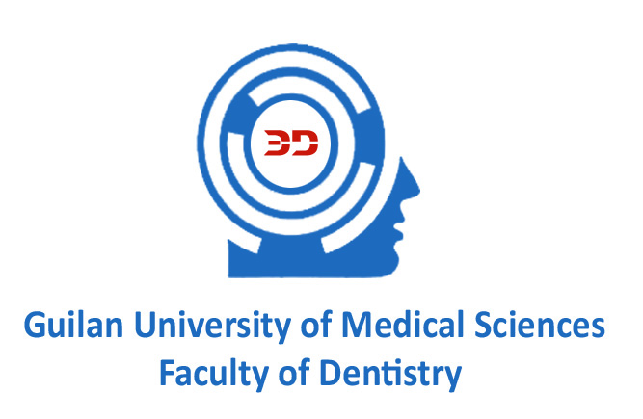

*Journal of Dentomaxillofacial*

*Radiology, Pathology and Surgery*

No:

Date:

Attachment:



Address: The end of professor Samii Blv, Guilan university of medical sciences complex, Dental School, Rasht, IRAN.   
P.C. 4194173774 Phone: +98-131-3263628 Fax: +98-131-3263623[www.gums.ac.ir/dental](http://www.gums.ac.ir/dental) E-mail:den3djournal@gums.ac.ir

Guilan University of Medical Sciences

Faculty of Dentistry

**Copyright and Conflict of Interest Statement**

We, the authors named below, certify that there is no conflict of interest regarding our article entitled **---------------------------------------------------------------------------------**”. which we are now submitting here to the Journal of DentomaxillofacialRadiology, Pathology and Surgery (3D).

We also confirm to value that the final right is reserved for the journal to incorporate any changes deemed necessary by the editorial board to the text of the article to be in harmony with the editorial standards of the journal. We are also aware of the fact that accepted papers become the permanent property ofthe Dentomaxillofacial Radiology,Pathology and Surgery (3D).

**Signature and Date**

**Corresponding Author … ………….... Co-Author**

**Co- Author…… ……………………….. Co- Author…………………….**